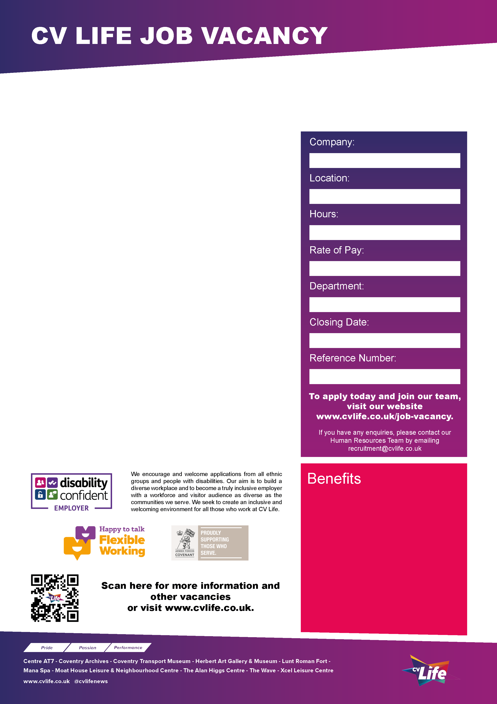
CV Life is committed to safeguarding and promoting the welfare of children and vulnerable adults and expects all staff and volunteers to share this commitment.
DBS clearance will be required for the successful candidate.
Please visit our website for further details: www.cvlife.co.uk/dbs
We are looking for enthusiastic and creative Casual Learning Facilitators to deliver engaging activities and events as part of our Learning and Engagement programme across the Herbert Art Gallery & Museum, Coventry Transport Museum and the Lunt Roman Fort.

You will work with a wide range of audiences including children, families, schools, and community groups, supporting the delivery of workshops, outreach sessions, and events such as birthday parties, holiday activities, and museum sleepovers. This is a flexible, hands-on role ideal for someone who enjoys working with people, is confident leading activities, and is passionate about creating memorable learning experiences in a museum and community setting.

There are several positions available for this role.

Interviews are proposed for W/C 18th May 2026

Apply today and join our team!
Casual Learning Facilitator
- Great development opportunities
- FREE health and fitness membership* **
- FREE health and fitness membership for a family member or friend* **
- FREE onsite parking at most sites
- FREE training for applicable roles
- DISCOUNTS on various Centre activities*
- FREE entry to venues*
- Access to our Employee Benefits platform

( **The two benefits combined can be worth £1000!)
(*not applicable to casual workers)

CCT089
10th May 2026
Learning and Engagement
NLW/NMW
Zero Hours
Multi Site
Culture Coventry Trust

