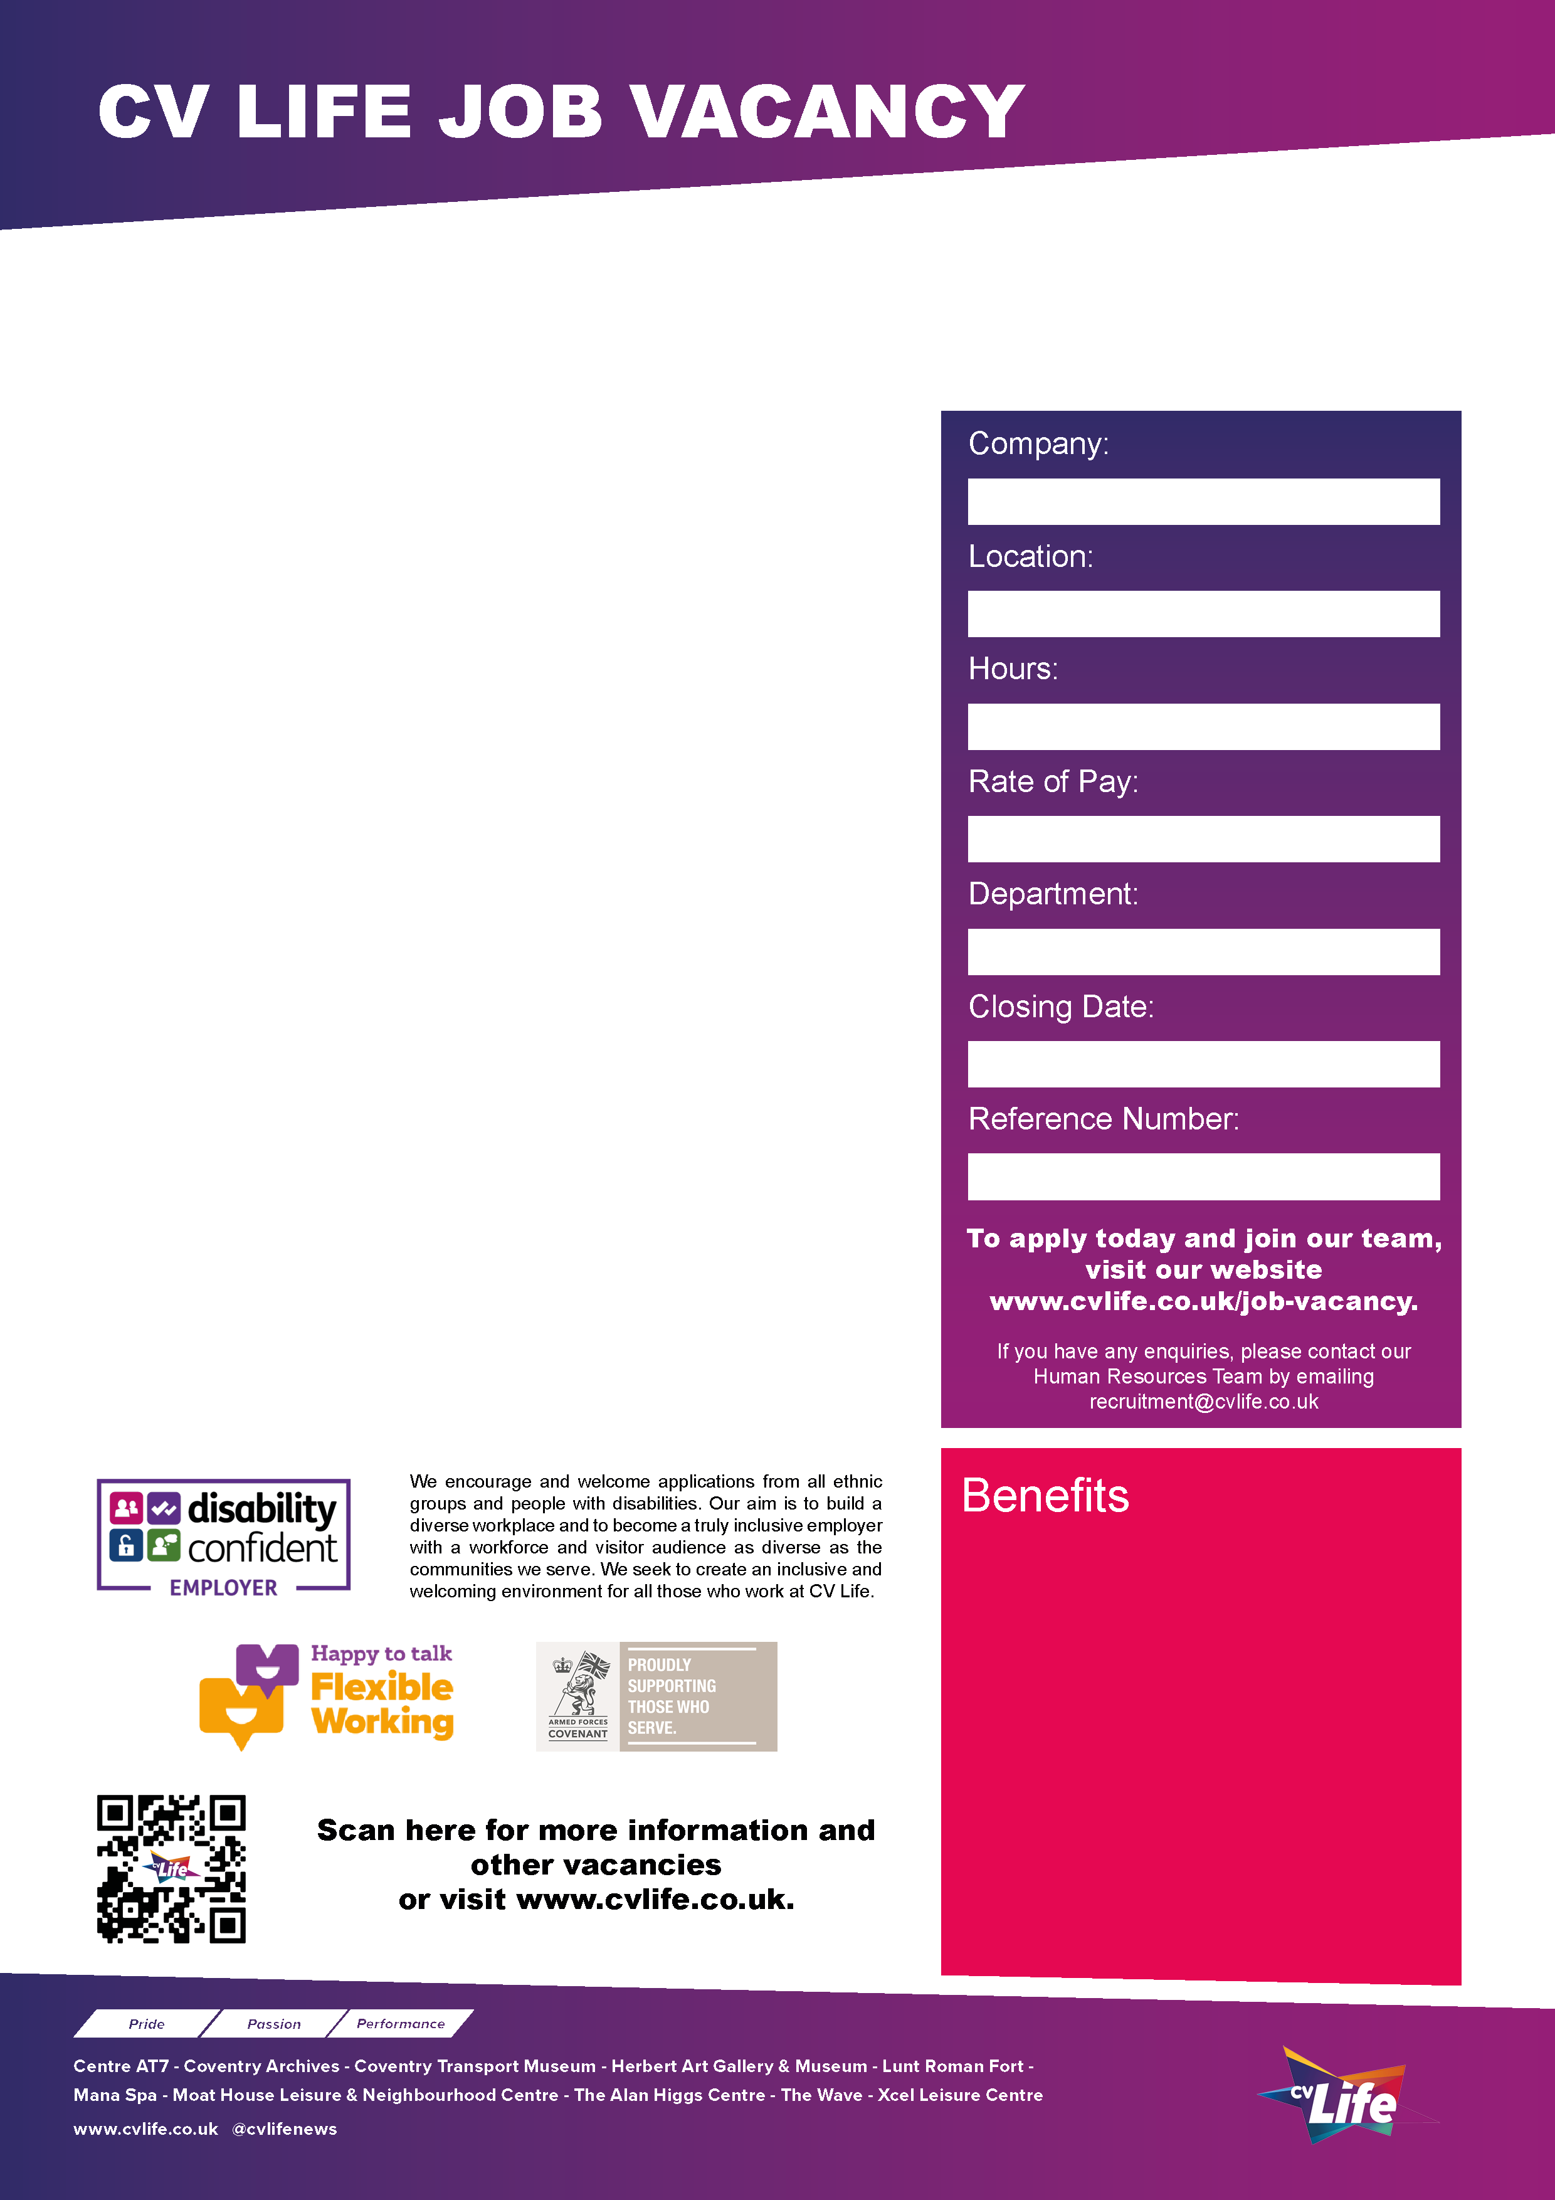
CV Life are looking for individuals to be part of a team of Christmas Elves, helping Santa within a Christmas scene setting as part of our iconic vintage Sleigh Ride Experience at the Coventry Transport Museum. We are seeking individuals who love the festive season and can bring joy and enthusiasm to our visitors. You will have a passion for the magic of Christmas and understand the importance of the role of Santa and his Elves for children, demonstrating the required behaviours with confidence and enthusiasm.

Becoming one of Santa’s Elves is a truly magical task. It’s not just about helping children feel at ease with the wonderful experience of seeing Santa, it’s about keeping the spirit of Christmas alive which means fantastic customer service and always looking for an opportunity to make people smile. Our Elves play a key role in ensuring our visitors have the best Christmas experience. You will be responsible for helping spread the Christmas spirit through creating memorable visits for children and their parents.

Main duties include:
Ensure a seamless end to end experience of the Grotto for Visitors. • Greet Visitors on arrival while promoting the excitement of meeting Father Christmas. • Ensure the smooth running of Santa’s Workshop • Efficiently promote learning activities • Efficiently deliver great photos of Father Christmas and his visitors. • Seamlessly and efficiently manage space and queues, so that no exits are blocked while engaging with visitors. • Ensure that all Sleigh ride visitors are taken onto and off the Sleigh safely. • Assist Father Christmas change overs, ensuring that the change takes place without any issues. • Assisting with the Grotto area, making sure it is clean and set up for the next day. • Adhere to safeguarding procedures. • Follow the Sleigh Visitor Engagement rules

There are morning and afternoon shifts from November -23rd Dec. Predominantly Sat and Sun shifts available.
If you can add a sprinkle of magic to our Christmas experience apply today!

CV Life is committed to safeguarding and promoting the welfare of children and vulnerable adults and expects all staff and volunteers to share this commitment.
Christmas Elf (Casual)
- Great development opportunities
- FREE health and fitness membership* **
- FREE health and fitness membership for a family member or friend* **
- FREE onsite parking at most sites
- FREE training for applicable roles
- DISCOUNTS on various Centre activities*
- FREE entry to venues*
- Access to our Employee Benefits platform

( **The two benefits combined can be worth £1000!)
(*not applicable to casual workers)

CCT076
20th October 2025
Commercial
NLW/NMW
Casual Hours (Temporary Contract)
Coventry Transport Museum
Culture Coventry

